Pre-Registration | Monday, October 19th, 2026
6:00 pm – 8:00 pm | Pre-Registration  F: ONWAA and Ishkoday Staff  Lobby
Day 1 | Tuesday, October 20th, 2026
7:30 am -9:00 am | Registration & Coffee
8:30 – 9:30 | Regional Board Meeting for Ishkoday and ONWAA  All Member Meet and Greet  Regional Sessions – Meet with your Board Member  Region 1 – David Fiddler  Region 2 – David Kelly  Region 3 – Elizabeth Ferris  Region 4 – Emma Recollet  Region 5 – Pauline Copegog
 | BREAK
9:45 am – 10:15 am | MC: Adam McLaren  Opening Prayer and Greeting  Elder and Drum  Opening Comments  ONWAA/Ishkoday President/Chair – Samantha Maracle  ONWAA/Ishkoday Executive Director – Jessica Nadjiwon
10:15 am-11:10 am | TBA
11:10 – 12:00 pm | Reconnecting to our Roots – Priscilla Yellowhead Tobey
12:00 - 1:00 pm | Lunch provided – Awards  Membership Vote on Audit
1:15 pm- 2:30 pm | IESO Programming Focus Group  F: IESO and Chelsea Brunelle, Ishkoday | Income Assistance Reform  F: AFN tentative | Energy as a Relationship  F: Nick Puran, Ishkoday
1:15 pm- 2:30 pm | Assignment of Benefits  F: Mycah Panjaitan, ONWAA | Hydro One LEAP Applications  F: OESP Team, Ishkoday | ACSD  F: TBA
2:45 – 4:30 pm | IESO Programming Focus Group  F: IESO and Chelsea Brunelle, Ishkoday | Ontario Energy Support Program  F: OESP Team, Ishkoday | Discretionary and TSF  F: Keith Nadjiwon, ONWAA
 | Navigating Ontario Works Technology Software  F: Kelsey LeBlanc, ONWAA | ONWAA Pharmaceutical Research Report Back  F: Owen Cober, ONWAA | MCCSS Showcase –  ODSP Remote Access  F: MCCSS
4:30 pm | Close for the Day

Day 2 | Wednesday- October 21st, 2026
8:30 am-9:00 am | Please go to your chosen workshop for the day
9-4 pm | Financial Literacy  F: Origin
Coaching Through a Trauma Informed Lens
F: Staci Williams
Energy Poverty Bootcamp
F: Adam McLaren
9:00 am-12:00 pm | ½ Day Sessions
9:00 am-12:00 pm | Bereavement and Grief for Frontline Staff  F: Krista Hunt, ONWAA | Walking Stick Workshop – Priscilla Yellowhead Tobey |  | Carrying the Fire Together: First Nations Systems Leadership in Response to Energy Poverty  F: Marcie Romenco |  |  | Decolonizing our Social Work Practice  F: Jay Lomax, Bachelor of Indigenous Social Work Instructor |  |  | Showcase:  Designing a Community based Income Assistance Program  F: Kelsey LeBlanc
12:00 pm-1:00 pm | LUNCH (on your own)
1:00 pm-4:00 pm | ½ Day Sessions
1:00 pm-4:00 pm | Protecting our First Nations Elders  F: Angela Ritchie, ONWAA |  |  |  | Energy Efficiency Consumer Training Showcase  F: Richard Carreiro, Ishkoday |  |  | Keeping the Circle Strong: First Nations Human Services in Two Worlds  F: Marcie Romenco |  |  | Artificial Intelligence – Concerns for Data Sovereignty  F: Owen Cober
Day 3 | Thursday- October 22nd, 2026
8:30 am-9:00 am | Please go to your chosen workshop.
9:00 am-12:00 pm | ½ Day Sessions
9:00 am-12:00 pm | Bereavement and Grief for Frontline Staff  F: Krista Hunt |  |  | Energy Efficiency Consumer Training Showcase  F: Richard Carreiro, Ishkoday Energy  Workshop |  |  | Artificial Intelligence – Concerns for Data Sovereignty  F: Owen Cober |  |  | Culturally Appropriate Employment and Training  F: Keith Nadjiwon, ONWAA
9:00 am-12:00 pm | Business Continuity Best Practices  F: Mycah Panjaitan |  |  |  |  | Protocols for Engaging with Indigenous People  F: Gord Downey and Chanie Wenjack Foundation
9:00 am-12:00 pm | Energy - TBA
12:00 pm-1:00 pm | LUNCH (on your own)
1:00 pm-2:15 pm | ½ Day Sessions
1:00 pm-2:15 pm | Energy as a Relationship  F: Nick Puran |  |  |  | Report Back on Energy Poverty Research in First Nations  F: Adam McLaren | Discretionary and TSF  F: Keith Nadjiwon, ONWAA |  |  |  |  | Report back on IA Design Workshops – What we Heard  F: Staci Williams, ONWAA
1:00 pm-2:15 pm | FNSSAC Students Meet and Greet  F: Mycah Panjaitan |  | Homemakers Client Forms  F: Jessica Nadjiwon, ONWAA |  |  | The Price of Welfare: Exploring Narratives of First Nations Economic Development in Ontario's Bill 5  F: Owen Cober |  |  | Report Back on the Market Basket Measure  F: Chelsea Brunelle
2:30 – 3:00 | Closing in Main Ballroom – Kelsey LeBlanc

Pre-Registration - October 19th from 6:00 pm – 8:00 pm.
We are encouraging attendees to pre-register for the two-day event at this time. We are attempting to avoid long lines and delays day of the assembly.
Vendors: All vendors will be located
Administrators Only Regional Sessions
These sessions are for the First Nations Ontario Works and Homemakers Staff to meet with members of their Board.
Region 1 – David Fiddler and Chelsea Brunelle, Ballroom
Region 2 – David Kelly and Victoria Zultek, Carlyle
Region 3 – Elizabeth Ferris and Mycah Panjaitan, Scott
Region 4 – Emma Recollet and Ritchie Carriero, Wren
Region 5 – Pauline Copegog and Keith Nadjiwon, Turner
Other Regions – Jessica Nadjiwon, Ballroom
Opening/Closing Protocols, Plenary and Guest Speakers
MC: Adam McLaren
Opening Prayer: David B. Fiddler - Drum: TBA
Opening Remarks: ONWAA President – Samantha Maracle & ONWAA Executive Director – Jessica Nadjiwon
TBA
Reconnecting to our Roots – Priscilla Yellowhead Tobey
Lunch and Awards

October 20th - Workshop Descriptions All sessions are 1.15 hours long
IESO Programming Focus Group
F: Chelsea Brunelle
Audience: Everyone
Description: Comment on how the IESO’s programs are helping low and middle class individuals in the province of Ontario

Income Assistance Reform Presentation
F: AFN and the Institute of Fiscal Studies and Democracy
Audience: For those new to their positions in community
Description: This session will provide an overview of the income assistance costing work, that the AFN and the Institute of Fiscal Studies and Democracy are completing for the IA reform. There will be opportunities for questions afterward.
Energy as a Relationship
Facilitator: Nick Puran , Ishkoday
Audience: Everyone
Description: What effect does energy have on wellbeing? What if we viewed energy not as a commodity but rather as a relationship between people, place, and time? Building on the Healthy Homes training, we will explore exactly why our relationship with energy matters and how it affects all areas of wellbeing – physical, emotional, and spiritual.

Themes we will explore in this workshop include:
- How energy is viewed around the world – East, West, and Indigenous Perspectives
- What academia says (studies on wellness in homes)
- How energy choices can be dictated by race, income, geography, disability, and housing status – what kind of relationship do we have with energy when it’s something to fear (disconnects, high bills, etc.)? Why is reducing energy not always virtuous?
- Nested systems – how natural systems (biodiversity, ecology) play a role
- What a healthy relationship with energy looks like
- Perspectives from a Homemaker
Assignment of Benefits
Facilitator: Mycah Panjaitan
Audience: Ontario Works Administrators, Staff and MCCSS
Description: Assignments of Benefits are mandatory forms for those waiting on receiving employment insurance. Come learn how to complete and submit the forms.

Hydro One LEAP Applications
Facilitators: Gene Taylor, Rhonda Howells and Kara McLeod
Description: This session will be a review of how Hydro One Remotes LEAP applications need to be completed and submitted to the Ishkoday team.

ACSD
Facilitator: TBA
Audience: Everyone
Description: This session will provide an overview of the applications process for the Assistance for Children with Severe Disabilities Program

Sessions from 2:45 pm to 4:30
IESO Programming Focus Group
F: Chelsea Brunelle
Audience: Everyone
Description: Comment on how the IESO’s programs are helping low and middle class individuals in the province of Ontario

Ontario Electricity Support Program
Facilitator: OESP Team
This is an overview of the program and the application process for both income assistance referrals from Ontario Works offices and manual verifications and how to get our team to come and visit your community.
Discretionary and TSF
F: Keith Nadjiwon
Audience: Everyone
Description: As of 2018, the Discretionary Benefits cap was removed for First Nation Ontario Works Delivery Agents ensuring benefits, including housing related costs, are available to social assistance recipients (OW and ODSP) on a case-by-case basis for a variety of health related and non-health related purposes. While Discretionary Benefits are only available to social assistance recipients, Transitional Support Funding (TSF) is available to support low-income individuals and families living on-reserve for housing-related benefits. Administrators are encouraged to develop local policies on the issuance of Discretionary Benefits and TSF that are consistent and reflective of community needs.

Navigating Ontario Works Technology
F: Kelsey LeBlanc
Audience: Everyone
Description: This 1.5 hour session will help participants understand the different technology software that is available to First Nation Ontario Works Delivery Agents (Social Assistance Management System (SAMS) and AD Morrison). Information is being provided, especially for those First Nations that are interested in delivering ODSP, in order to make an informed decision on what software to use. Some of the topics that will be covered are: Privacy laws, Accessibility of third-party verification, Capabilities of each software system. Participants will have an opportunity to share experiences about the software that they utilize – e.g. what components they like about it or what desired features may not be included.
ONWAA Pharmaceutical Research Report Back
F: Owen Cober
Description: ONWAA has been researching barriers to accessing pharmaceuticals since January 2025, and has produced multiple reports on the topic. This session will focus on the most recent report, outlining how the research was conducted, the key findings of the report, and what actions can be taken to work towards self-determination for First Nations in the pharmaceutical sector.

MCCSS Hold Session
Day Two - October 23rd – All Day Sessions
Financial Literacy
F: Origin
Description:
Audience: Everyone
Description: Participants will learn a framework for introducing Financial well-being to their clients. Grounded in the medicine wheel, this framework helps people to see their financial health through a different lens.

Coaching thru a Trauma Informed Lens
F: Staci Williams
Audience: Ontario Works Administrators/Staff and Homemakers Coordinators
Description: Trauma informed care requires an understanding how historical trauma and experiences can impact an individual, community, and front-line workers. This session will provide an overview of the core principles of trauma informed care, with emphasis on coaching and emotional intelligence competencies required to effectively coach and motivate individuals.

Energy Poverty Bootcamp
F: Adam McLaren
Audience: Everyone
Description: Ishkoday’s Energy Poverty Bootcamp is an intensive (1) day course that creates an open and shared learning environment to collaboratively examine First Nations stark realities in working with the Energy Sector through a cultural competency lens. The course is designed to be high impact, revealing stark realities while also being interactive and collaborative. Our course covers the following subjects: Indigenous Customs, Bias and Privilege, Examining Worldviews, Terminology , Indigenous ways of knowing and governance, History of Colonization, Generational Trauma, Review of Energy Poverty concepts, Energy Poverty in First Nations Statistics, Examination of First Nation barriers to Energy Efficiency.

½ Day Workshops Morning

Bereavement and Grief for Frontline Staff
F: Krista Hunt
Audience: Homemakers Coordinators
Description:
Carrying the Fire Together: First Nations Systems Leadership in Response to Energy Poverty
F: Marcie Romenco
Audience: Everyone
Description: The overarching goal of this workshop would be to support First Nation Social Service Administrators in examining how energy poverty is landing in social assistance administration as workload, role confusion, staff pressure, emergency response, and systems frustration. Rather than duplicating Ishkōday’s energy training, program navigation, or program-information work, this session would focus on the administrative and systems-level impacts of energy poverty.
This workshop would also be grounded in Indigenous social work principles, circle work, smudging, and facilitated dialogue. Participants would examine what administrators are currently carrying, what can be shared with partners, what should be set down because it belongs to broader systems, and what can be built collectively. The session would also explore how repeated energy-related issues could be documented and transformed into evidence for broader systems change, collective advocacy, and stronger support for First Nation social assistance systems.

Decolonizing our Social Work Practice
F: Jay Lomax, Bachelor of Indigenous Social Work Instructor
Audience: Everyone
Description: This session explores how to shift social work away from colonial foundations toward practices rooted in Indigenous knowledge and sovereignty. It outlines the historical harm caused by systems like the child welfare industry, emphasizing the need to move beyond western models that prioritize individual compliance over community healing. Participants will find frameworks for centering Indigenous worldviews, honoring kinship systems, and advocating for self-determination. By prioritizing cultural safety and land-based approaches, social workers can help dismantle power imbalances and support the resilience of Indigenous families and nations.
Showcase: Designing a Community Based Income Assistance Program
F: Kelsey LeBlanc, ONWAA
Audience: Everyone
Description: This showcase we will be an introduction into the new four module program that will be offered in 2027-2028 where over the course of a year for any individuals who are interested in facilitating conversations will be able to learn the skills to design their own income assistance program. This new curriculum will provide comprehensive training to equip participants with facilitation skills, research and development skills. In addition, the training program will provide tools and strategies for change management and program design. Each module is four days in duration for a total of 16 days of train the trainer curriculum, tools, and delivery.

Wednesday - Afternoon Sessions
Protecting our First Nations Elders
F: Ange Ritchie, ONWAA
Audience: Homemakers Coordinators and Homemakers
Description: This workshop will provide an in-depth explanation of what Elder mistreatment is, the types of mistreatments that elders may endure and how we as communities can work together to prevent Elder mistreatment. Participants will learn how Elder mistreatment can affect everyone in the community and find their role in supporting them.
Showcase: Energy Efficiency Consumer Training
F: Richard Carriero
Audience: Everyone
Description: This showcase walks participants thru the free training we provide in First Nations consumers. The training will provide participants with knowledge and understanding of the following concepts: Home Basics, Terminology, Energy Efficiency, and Challenges for First Nations. Learners will explore energy production, healthy homes, and how to save on energy usage. Learners will connect, reflect, and apply principles of energy efficiency to reduce energy poverty as it relates to the unique challenges of First Nations communities.

Keeping the Circle Strong: First Nations Human Services in Two Worlds
Facilitator: Marcie Romenco
Audience: Those working in Human Services
Description: The overarching goal of this workshop would be to create a culturally grounded and supportive space for First Nation Social Service Administrators to reflect on the realities of working in two worlds. The session would focus on how administrators can remain grounded in First Nations values, culture, responsibility, and community wellness while also navigating colonial legislation, compliance requirements, funding restrictions, and organizational pressures. This workshop would be grounded in Indigenous social work principles, circle work, smudging, storytelling, and facilitated dialogue. It would create space for participants to name what they are carrying, recognize that they are not alone, and explore practical ways to maintain balance, role clarity, cultural grounding, peer support, and collective strength while working within systems that often do not reflect First Nations realities.
Artificial Intelligence – Concerns for Data Sovereignty
F: Owen Cober
Audience: Everyone
Description: This training will review what AI is, look at common types, describe how it can be used, how it can be worked with, and discuss ethics, risks and benefits of the use of AI from an Indigenous lens.
Thursday October 22nd, 2026 – Morning Sessions
Bereavement and Grief for Frontline Staff
F: Krista Hunt
Audience: Homemakers Coordinators
Description:
Showcase: Energy Efficiency Consumer Training
F: Richard Carriero
Audience: Everyone
Description: This showcase walks participants thru the free training we provide in First Nations consumers. The training will provide participants with knowledge and understanding of the following concepts: Home Basics, Terminology, Energy Efficiency, and Challenges for First Nations. Learners will explore energy production, healthy homes, and how to save on energy usage. Learners will connect, reflect, and apply principles of energy efficiency to reduce energy poverty as it relates to the unique challenges of First Nations communities.
Artificial Intelligence – Concerns for Data Sovereignty
F: Owen Cober
Audience: Everyone
Description: This training will review what AI is, look at common types, describe how it can be used, how it can be worked with, and discuss ethics, risks and benefits of the use of AI from an Indigenous lens.
Culturally Appropriate Employment and Training
F: Keith Nadjiwon, ONWAA
Audience: Everyone
Description: This session will explore approaches to designing and delivering employment and training programs that are culturally appropriate and reflective of community priorities. Participants will learn how life stabilization supports and addressing barriers to participation can help achieve meaningful employment outcomes while reconnecting with traditions. Participants will learn about culturally appropriate employment and training programs that can be applied to their Employment Program. Participants will learn how Life Stabilization can be applied to their Employment Program.
Business Continuity Best Practices
F: Mycah Panjaitan, ONWAA
Audience: Everyone
Description: Emergency situations can occur unexpectedly, from pandemics, cyber-attacks, hydro or water outages, natural disasters, and community evacuations. As part of the Ontario Works Service Plan you will be requested to plan for business continuity in the event of an emergency within your community. However other staff working in community and for organizations should consider what goes into a business continuity plan. It is expected that you will be able to service individuals regardless of the emergency. Being prepared is crucial to increasing community safety, building community resiliency, and ensuring business continuity. Participants will gain knowledge and tools to develop and implement emergency preparedness and business continuity plans within their communities.
Protocols for Engaging with Indigenous People
F: Gord Downie & Chanie Wenjack Fund
Audience: Everyone
Description: The term Indigenous Protocols is becoming commonplace within organizations to improve processes in day-to-day interactions with Indigenous Peoples and communities. The concept of Indigenous Protocols varies from nation to nation, community to community; however, it is not a prescribed set of rules or behaviours that must be adhered to. It is a principle-based approach to how interactions occur cross-culturally to ensure respectful engagement with Indigenous Peoples and communities.
Energy
F: TBA
Audience: TBA
Description: TBA
Thursday Afternoon 1-2:30 pm Sessions
Energy as a Relationship
Facilitator: Nick Puran , Ishkoday
Audience: Everyone
Description: What effect does energy have on wellbeing? What if we viewed energy not as a commodity but rather as a relationship between people, place, and time? Building on the Healthy Homes training, we will explore exactly why our relationship with energy matters and how it affects all areas of wellbeing – physical, emotional, and spiritual.
Themes we will explore in this workshop include:
- How energy is viewed around the world – East, West, and Indigenous Perspectives
- What academia says (studies on wellness in homes)
- How energy choices can be dictated by race, income, geography, disability, and housing status – what kind of relationship do we have with energy when it’s something to fear (disconnects, high bills, etc.)? Why is reducing energy not always virtuous?
- Nested systems – how natural systems (biodiversity, ecology) play a role
- What a healthy relationship with energy looks like
- Perspectives from a Homemaker
Report Back on Energy Poverty Research in First Nations
F: Adam McLaren
Audience: Everyone
Description: This report back will look at the research Ishkoday has done to date on the energy poverty issues within First Nations communities in Ontario.
Discretionary and TSF
F: Keith Nadjiwon, ONWAA
Audience: Everyone
Description: As of 2018, the Discretionary Benefits cap was removed for First Nation Ontario Works Delivery Agents ensuring benefits, including housing related costs, are available to social assistance recipients (OW and ODSP) on a case-by-case basis for a variety of health related and non-health related purposes. While Discretionary Benefits are only available to social assistance recipients, Transitional Support Funding (TSF) is available to support low-income individuals and families living on-reserve for housing-related benefits. Administrators are encouraged to develop local policies on the issuance of Discretionary Benefits and TSF that are consistent and reflective of community needs.

Report Back on IA Design Workshops
P: Staci Williams, ONWAA
Audience: Membership
Description: ONWAA developed and delivered “Designing Culturally Appropriate Income Assistance Programs” workshops over a two-year period. These sessions were designed to intentionally decolonize thinking and explore various world models of income assistance to review, compare and recommend changes to current income assistance programs. Over 100 participants shared feedback and key recommendations will be presented to membership.

FNSSAC Students Meet and Greet
F: Mycah Panjaitan
Audience: Current FNSSAC Students Only
Description: An opportunity for this years FNSSAC participants to meet in-person before the in-class portion of their studies.
Homemakers Forms
F: Jessica Nadjiwon
Audience: Homemakers Coordinators
Description: This is a refresher on when to complete the Form 4, and what are the file requirements for all of the forms when delivering the Homemakers Program.
“The Price of Welfare: Exploring Narratives of First Nations Economic Development in Ontario’s Bill 5”
Presenter: Owen Cober
Audience: Everyone
Description: This research explores how the government of Ontario uses arguments related to First Nations economic development to justify the expansion of mining in Ontario. It will show that the language used by the Progressive Conservative Government of Ontario perpetuates longstanding colonial dynamics, further subordinating First Nations rights to the economic interests of the province. This research was conducted by Owen Cober, ONWAA Research and Policy Analyst, as part of the requirements for his master's degree.

Report Back: ONWAA’s Market Basket Measure Projects
Presenter: Chelsea Brunelle
Audience: Everyone
Description: Join this session to hear the project’s lead researcher report back on the cost-of-living research that ONWAA has gathered through collaboration with First Nation community members across all 5 Ontario regions from 2022 to 2026. This session discusses key-findings and provides an understanding of how ONWAA collected data using the market basket measure threshold in a culturally appropriate manner. This unique research project illustrates a realistic picture of what it costs to live on-reserve in urban, rural, and remote areas based on actual monthly breakdowns of household costs.

This year’s logo’s:
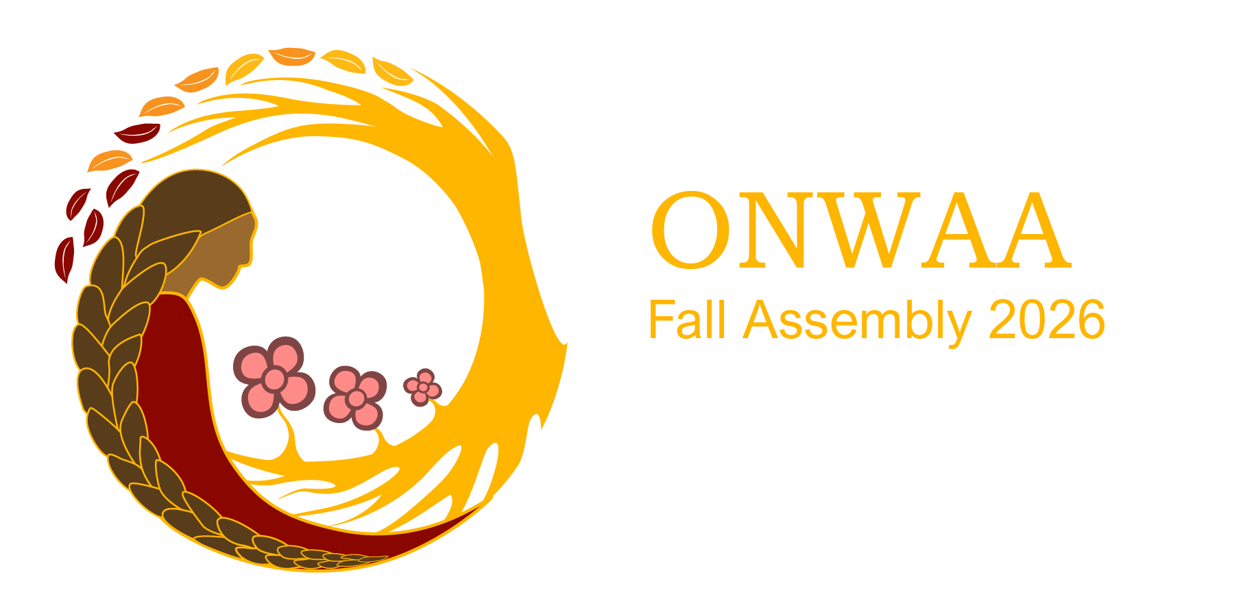

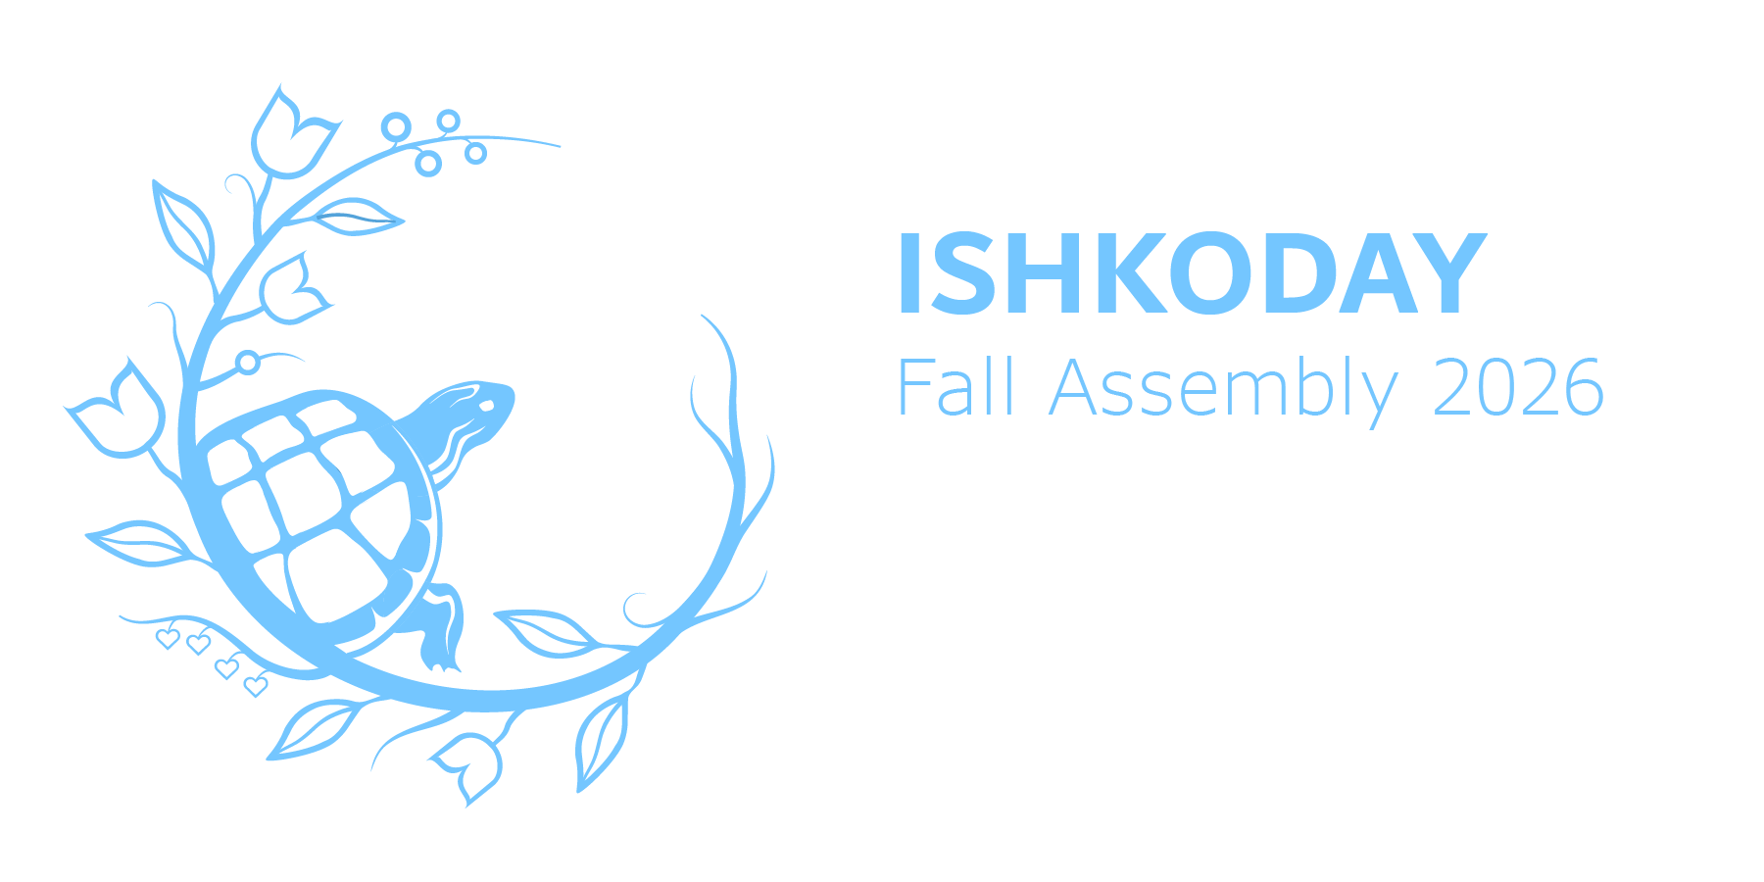
This year’s theme:
The theme for this year’s assembly is Reconnecting to our Roots. Join us as we reflect on the importance of First Nations cultural traditions, teachings, and sacred knowledge. Together, we will rekindle our connection to our roots by honouring the wisdom our of elders and ancestors and remembering our First Nations ways of knowing and being.

